Monday, 21 September 2026, postcard

Disembarkation day

The only item on today's agenda was the bus trip from the ship to our hotel in Cannes, but the cruise planners packed a lot into it so that we didn't have to sit in the bus for too long at a time. For once, the luggage pick-up took place after we left the ship, so we had the luxury of brushing our teeth before packing our wash kits and closing up our suitcases.

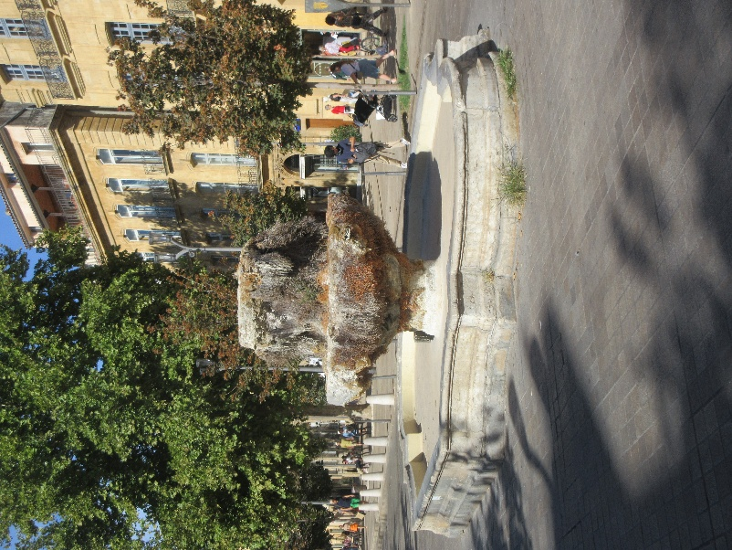
We pulled out at 8:30 am, and in midmorning, we took a break at a truck stop. Next, we arrived at Aix-en-Provence. We'd been there a couple of times and had a walking tour, so David found a pleasant park bench on the Cour Mirabeau and got out his book, while I scouted up and down the street for a good lunch venue. One of my favorite features of the Cour Mirabeau is the pair of natural warm-spring fountains, which are always green and flowery, even in the dead of winter. This year, one of them was covered with moss and ferns as usual, but the second, shown here, was dry and dead! I guess its spring couldn't cope with this terrible drought.

We were due to rendez-vous for departure at 1 pm, and annoyingly, all the restaurants opened only at noon! Fortunately, the last one I came to opened at 11 am, so we got a table and got our orders in in good time. I texted Rachel our location, so she was able to join us when the walking tour ended.

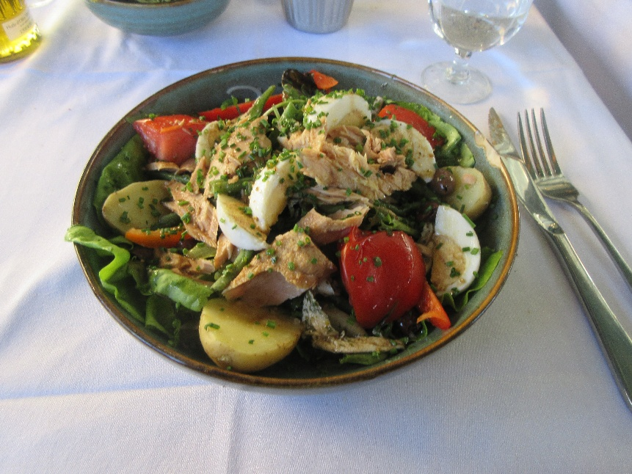
David enjoyed his beef tartare and fries, and I was very happy with this salade Niçoise, with fresh tuna. Rachel was delighted that they were willing to replace the tuna in hers with grilled chicken.

Back in the buses, we continued toward Cannes, but something had clearly gone wrong with the AC in our bus. By the time we reach our second truck stop break, it had gotten miserably hot in there. In the truck-stop parking lot, Tour Director Concetta suggested a rearrangement. Our next stop was to be the U.S. WWII Rhône Cemetery, but Concetta proposed that those who had no interest in that stop get in the hot bus, which would open its sky-light hatches and make a bee-line for the hotel in Cannes, while those of us who wanted to see the cemetery could take their places on the buses with AC (and no skylights) and make the intermediate stop, which would take longer. We wanted to see the cemetery, so we switched buses—the number of seats miraculously matched up—and we were off again.

A wall is engraved with the names of 294 missing service members. Since it was erected, eight have been found.

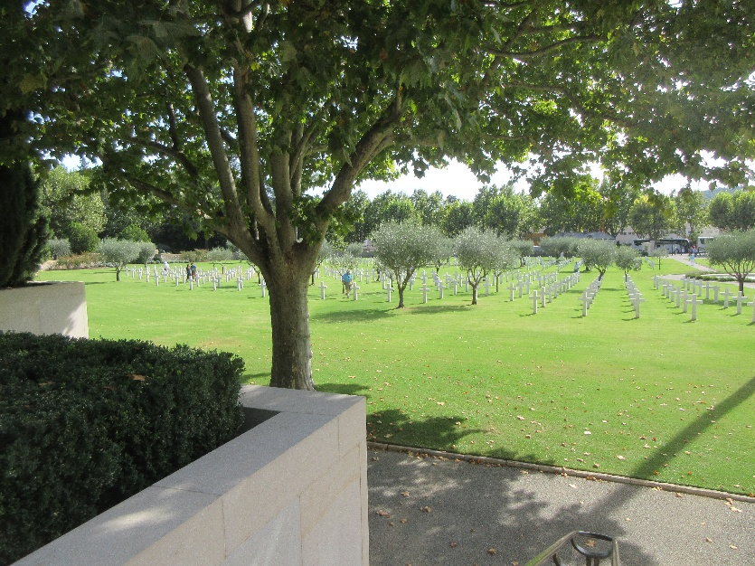
Like all such cemeteries, this one was beautifully laid out and cared for—it included between 800 and 900 graves, interspersed with olive trees. Also as usual, the chapel included a beautiful mosaic and was surrounded by maps explaining the campaign in which those buried there died—the invasion of the "underbelly" of France in August of 1944. We were each given a rose at the entrance, to lay at a grave of our choice. We happened to be there on Yom Kippur, and 15 of the graves were marked by stars of David. Rachel wept because she had time to say kaddish over only six.

We could tell when we reached Cannes, because walls began to be covered with huge portraits of movie stars.
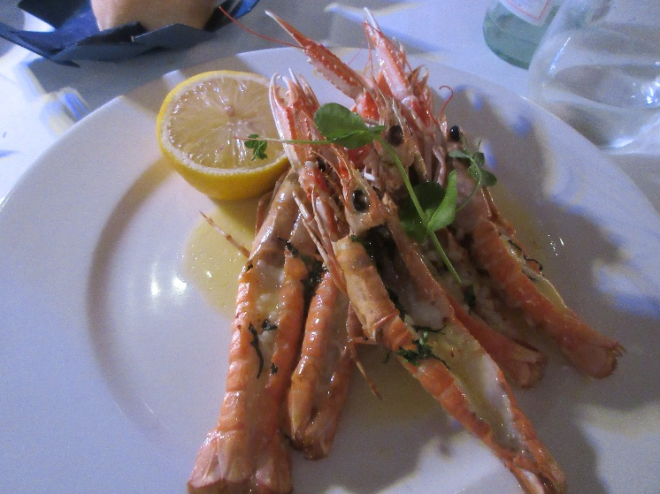
We checked into the J. W. Marriott on the Croisette—the ocean-front promenade. I had located a wonderfully promising French bistro (in a city dominated by Italian restaurants), but it was closed on Mondays, so we just had supper at the hotel's (Italian) restaurant.

I was pleased to be able to order scampi made with actual scampi (Nephrops norvegicus) rather than shrimp. They were outstanding.

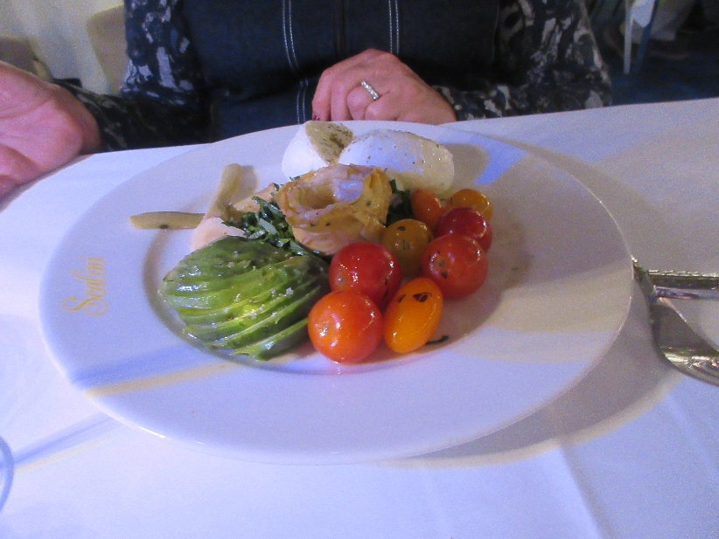
Rachel was delighted with her "avocado Scalini," which we're going to try to recreate at home.

My osso bucco was pretty good, but Rachel and David were so disappointed with their veal with Gorgonzola and green peppercorn sauce—overcooked to the point of being hard and tough—that both were removed from the bill.

